**Changes that need to be made on the Department of Economics’ Website**

**Forthcoming Events (website outlook Front Page)**

Nov Randomized Controlled Trials (RCTs) in the Social Sciences   
 3 Speaker(s): Ms. Anum Shoaib, CERP  
 Series: Faculty Development Workshop

Nov An Introduction to Geographic Information System (GIS) / Mapping  
 4 Speaker(s): Mr. Syed Uzair Junaid, CERP  
 Series: Faculty Development Workshop

Nov Monthly Meeting  
 11 Speaker(s): Rector, Deans and Directors  
 Series: Dean/Directors Meeting

Nov Research Paper Presentations  
 24 Speaker(s): Economics Faculty  
 Series: Faculty of Economics Departmental Meetings

Dec Board of Studies/Curriculum Committee Meeting  
 8 Speaker(s): Dr. Azam Chaudhry, Professor & Dean; Economics Faculty  
 Series: Faculty of Economics Departmental Meetings

Latest News (website **outlook Front Page)**

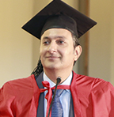

18/10/2016

Dr. Azam Chaudhry, Professor & Dean, inaugurates

the Lahore School Economics Society (LSES)

third annual orientation

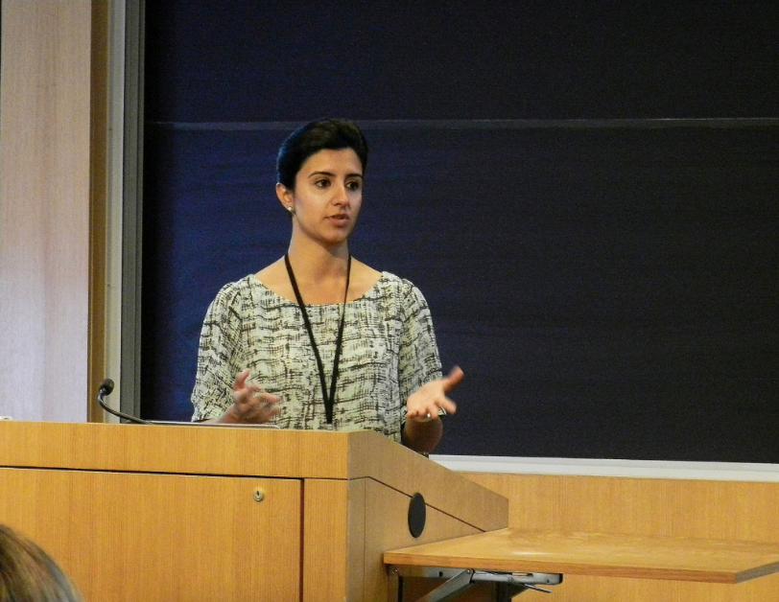

16/08/2016

Ms. Farah Said, Assistant Professor & Research Fellow

at CREB, Lahore School of Economics,

attends the conference on innovative economic

field experiments at University of Chicago, Illinois, USA

**PhD students of LSE visit Oxford University, UK**

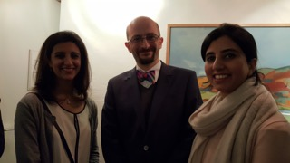

15/01/2016

Ms. Rabia Ikram, Assistant Professor & Research Scholar at the Lahore School of Economics

and Ms. Farah Said, Assistant Professor & Research Fellow of CREB

visited Oxford University, UK under this program in January, 2016

_________________________________________________________________________________________________________________________________

1. **Major Economics Department Collaborations ( make the following changes highlighted in yellow)**

**Major Economics Department Collaborations**

Lahore School of Economics has the following ongoing exchange programs with 6 international partner universities and 1 industrial collaboration with the Lahore Chamber of Commerce and Industry Collaboration (LCCI).

**Partner Universities:**

* Undergraduate Exchange Program with Macquarie University, Sydney, Australia
* Undergraduate Exchange Program with Bahcesheir University, Istanbul, Turkey
* Undergraduate Exchange Program with University of Colombo, Sri Lanka
* Undergraduate Exchange Program with University of Peradeniya, Kandy, Sri Lanka
* PhD. Economics Student Exchange Program with the University of Oxford, UK
* PhD. Economics Student Exchange Program with the University of Warwick, UK

**Industrial Collaborations:**

* Lahore School of Economics and Lahore Chamber of Commerce and Industry (LCCI) Collaboration

**______________________________________________________________________________________________________________________**

1. **Add the following highlighted with the links given below:**

**STAY CONNECTED**

**Facebook**

**Lahore School Alumni | Facebook**

**LinkedIn**

**Twitter**

**Instagram**

1. **Lahore School Alumni |  Facebook**

**https://www.facebook.com/LahoreSchoolAlumni/**

1. **LinkedIn**

**https://www.linkedin.com/company/lahore-school-of-economics?trk=prof-following-company-logo**

**_______________________________________________________________________________________________________________**

1. Tabs on economics website headings give errors ( when you clink on any tab by mistake it should either open the first link underneath or there should be no change. The following error should not come:

**Not Found**

The requested URL /economics/testing.php was not found on this server.

*Apache Server at admissions.lahoreschool.edu.pk Port 80*

___________________________________________________________________________________________________________________  
4- Make the following change highlighted changes in designation and qualification on Dr Shahid profile (Faculty)

Qualifications:

Ph.D, McGill University, Canada

MA (Cantab.), Cambridge, UK

BA, Punjab University, Pakistan

Professor & Rector, Lahore School of Economics

**_______________________________________________________________________________________________________________**

1. **Increase website size and heading and pics size ( overall outlook)**

**______________________________________________________________________________________________________________________**

1. **News Section (1st page), remove the double link highlighted below and give it a link to it can directly be opened by clinking on it:**

Special Edition of the Lahore Journal of Economics Launched

This year's issue of the Lahore Journal of Economics containing the papers and proceedings of the Lahore School's March 2016 conference on "Technology, entrepreneurship and productivity growth: Where Pakistan stands and where it must go" has been launched.

The conference brought together leading scientists, economists, industry-level specialists, business leaders and policymakers both from within Pakistan and abroad to discuss the key role of innovation and productivity growth at both the macro and the firm level.

The articles are available at:

http://www.lahoreschoolofeconomics.edu.pk/EconomicsJournal/volume21issuesp.aspx

http://www.lahoreschoolofeconomics.edu.pk/EconomicsJournal/volume21issuesp.aspx

We hope that you find the articles in the Special Edition interesting and we look forward to your feedback.

_________________________________________________________________________________________________________

1. **Please include one heading under Research Section as “Major Economics Department Projects” as highlighted below:**

** Department of Economics**

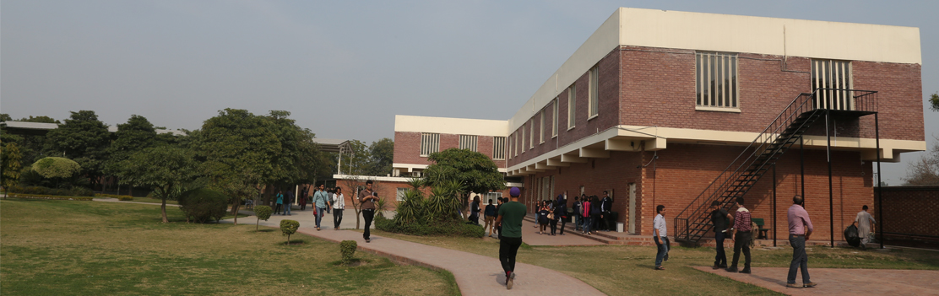

**Home People Research Prospective Students Events News & Media Contacts Us**

Faculty Centers  Undergraduate Programs Forthcoming Seminars News

 Researchers CREB Post-Graduate Programs External Events Media

 Graduate Students GIDS Economics Department Collaborations

 Technology Management & Innovation Centre  Past Events

Working Papers Annual Conference 2016

 CREB Working Papers  Annual Conference 2015

 Publications  Annual Conference 2014

 Lahore Journal of Economics (LJE)

 Economics Department Recent Publications

 Major Economics Department Projects

**QUICK LINKS PROSPECTIVE STUDENTS Useful Links STAY CONNECTED**

* [About Us](http://www.economics.ox.ac.uk/About-Us/about-us) Undergraduate *Programs*  Lahore School of Economics Facebook
* [Contact Us](http://www.economics.ox.ac.uk/index.php?option=com_contact&Itemid=230&id=53&lang=en&view=contacts) *Post-Graduate Programs* CREB LinkedIn
* [Degree](http://www.economics.ox.ac.uk/About-Us/finding-us) Programs GIDS Twitter

______________________________________________________________________________________________________________________

1. **Please include the following write up under “Major Economics Department Projects” which comes under Research:**

**Economics Department Major Research Projects**

**Incentivizing Attendance in Production Teams Dr. Theresa Chaudhry and Zunia Tirmazee**

The research team tested whether short-term financial incentives can be used to decrease worker absenteeism in one of Gujrat’s leading fan factories. In 2012 -2013, they piloted attendance incentive schemes on a sample of production teams. Comparing the attendance records of the teams offered the group-based incentive to a control group, the research team has found that the group-based incentive bonus increased the number of days that an announced attendance target was met.

The project was funded by the IGC and collaborators included Christopher Woodruff (University of Warwick) and Muhammad Haseeb (University of Warwick).

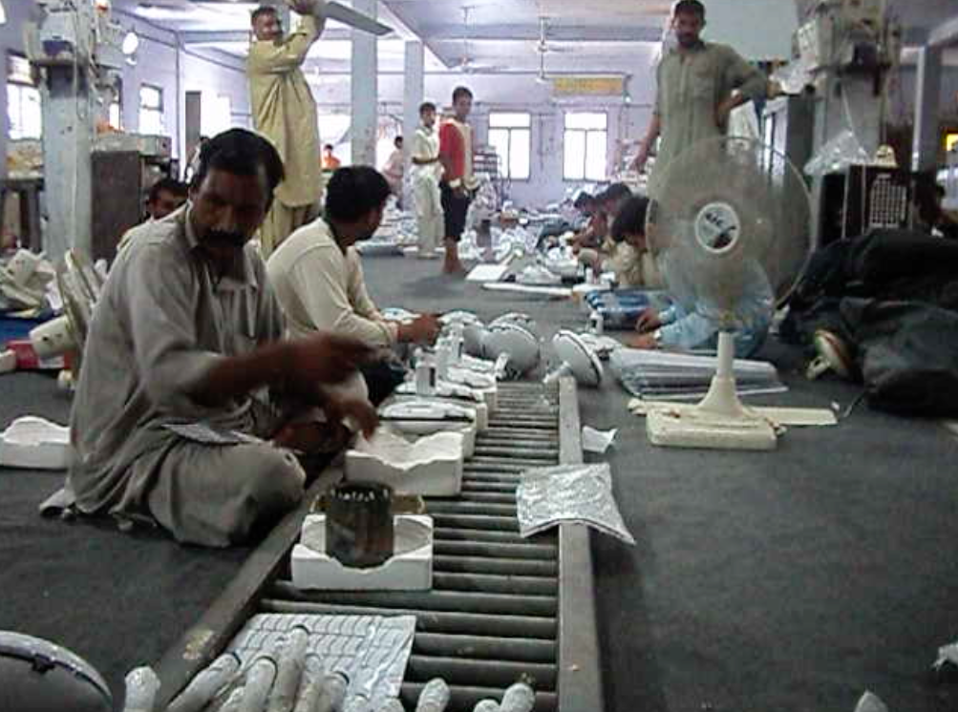

**______________________________________________________________________________**

**Causes and Consequences of Consanguineous Marriage in Pakistan Dr. Theresa Chaudhry**

The researchers examined the causes of consanguineous marriage, and attempted to measure the effects of consanguineous marriage, both negative and positive. In this project, nine (out of Punjab’s 35 districts) were randomly selected, comprising 70 sampling clusters. Interviews of just over 1000 households were conducted in October 2009.  A total of 4643 pregnancies were reported by 391 first cousin (37.6% of the marriages) and 622 non consanguineous couples interviewed in the study.

Collaborators include Mushfiq Mobarak (Yale University).

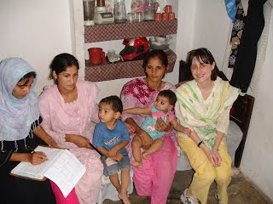

**____________________________________________________________________________________________________________**

**Conditional-Cash Transfers for Girls’ Secondary Schooling in Punjab: Outcomes Dr. Theresa Chaudhry**

The government of Punjab, starting in 2004, offered a conditional cash transfer (CCT) of Rs 200 per month, to girls in class 6 to 8 with minimum 80 percent attendance, in order to increase the educational attainment of girls in districts with less than 40 percent literacy.  Using data collected a survey of rural households in Punjab, the researchers analyzed the impacts of this CCT on enrollment and marriage outcomes by comparing eligible girls to their non-eligible elder sisters and younger siblings in both stipend and non-stipend districts.

This project was supported by the British Academy and Lahore School of Economics and collaborators include Mushfiq Mobarak (Yale University).

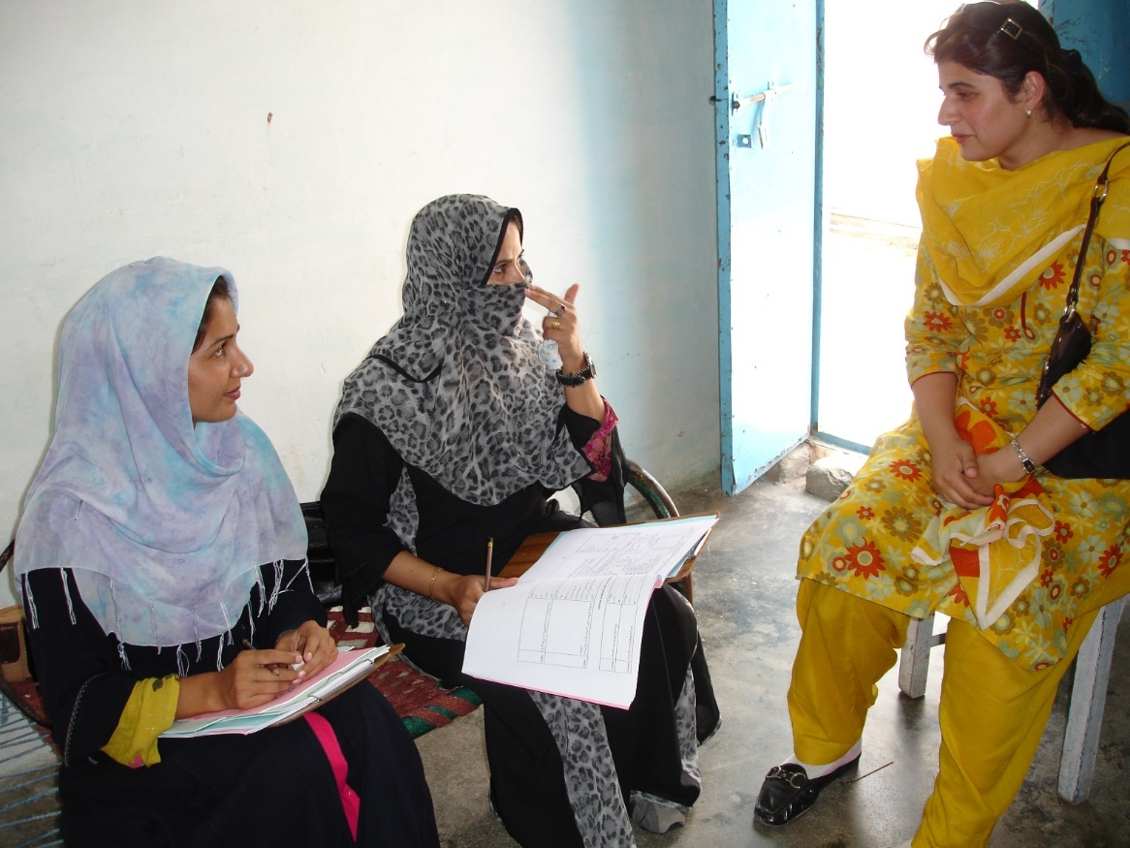

**____________________________________________________________________________________________________________**

**Rent-seeking, Government Size and Economic Growth Dr. Waqar Wadho and Umair Ayaz**

The research team is exploring the relationship between government size and economic growth in an endogenous growth model with human capital and unproductive social capital. The researchers show that with endogenous discounting, growth outcome is history dependent and is function of initial endowment of human capital. With low endowment, government intervention of any size is growth depressing. With high endowment, government intervention is not associated with any depressing effect. For intermediate levels, there are multiple equilibria. Furthermore, countries with identical endowment and government size can be in different equilibrium, and can have different growth rates within same equilibrium if they differ in institutional quality.

**___________________________________________________________________________________________________________**

**Two Sides of the Same Rupee? Comparing Demand for Microcredit and Microsaving in a Framed Field Experiment in Rural Pakistan Farah Said and Uzma Afzal**

The study is a Randomized Control Trial designed to compare the effectiveness of micro-savings and micro-loans as means for households to manage risk and liquidity.

This research is funded by the IGC and is collaboration between the Lahore School of Economics, the University of Oxford and the National Rural Support Programme (NRSP), Pakistan. Collaborators are Marcel Faffchamps (Stanford University), Giovanna d’Adda (University of Birmingham) and Simon Quinn (Oxford University).

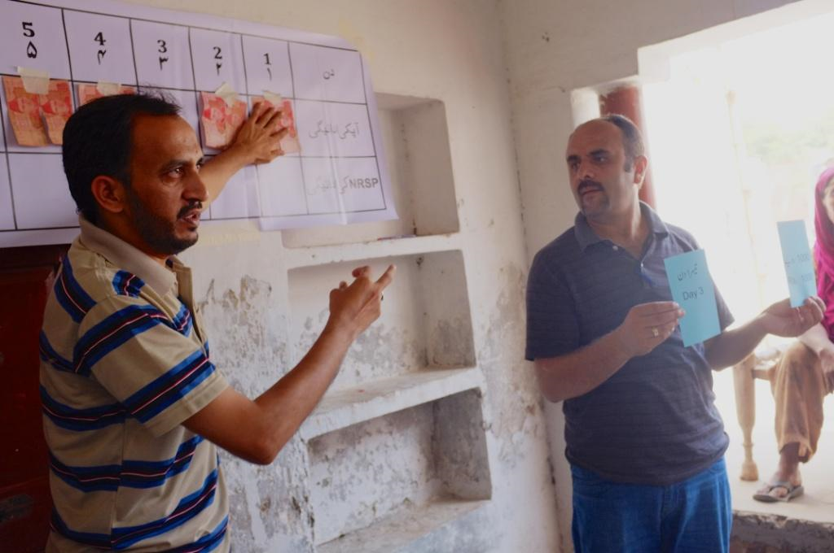

**____________________________________________________________________________________________________________**

**Impact assessment of startup loans to female run micro-enterprises Farah Said, Dr. Azam Chaudhry, Dr. Naved Hamid and Mahreen Mahmud.**

The study is an impact evaluation of a unique micro-loan product with a training component that is provided only to female borrowers to start-up their microenterprise.

Baseline activities were funded by the Kashf Foundation and were concluded in August 2014. Endline activities are being funded by the IGC.

This research is collaboration between researchers at the Lahore School of Economics, University of Kent, and the Kashf Foundation, Pakistan.

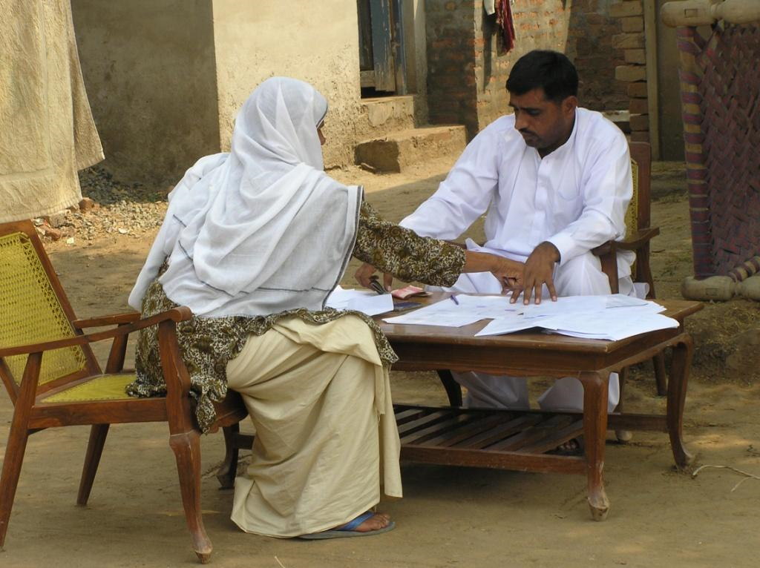

**____________________________________________________________________________________________________________**

**Pressures from peers and spouses and self-control problems as constraints to microenterprise growth: Experimental evidence from Pakistan Farah Said and Uzma Afzal**

This study is assessing the role of self-control problems and peer pressures on take-up and use of a financial product by female microentrepreneurs in Pakistan, by combining laboratory and field experiments.

This project is funded by the IGC and collaborators include Marcel Faffchamps (Stanford University) and Giovanna d’Adda (University of Birmingham).

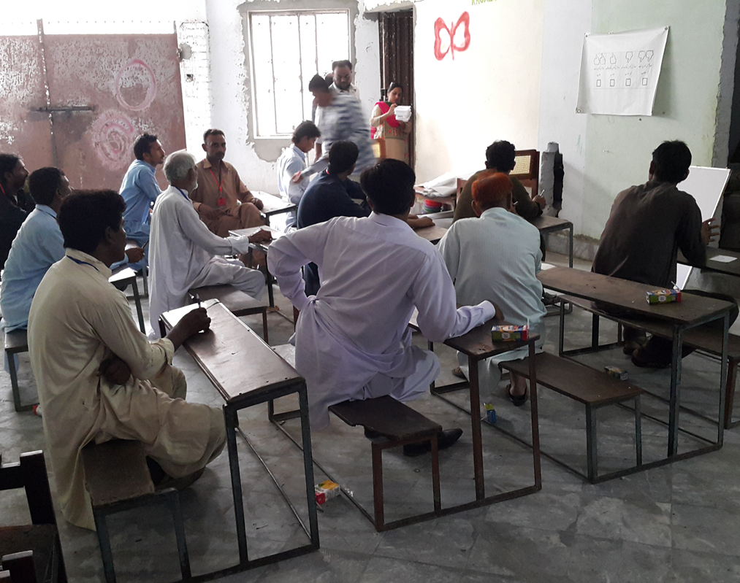

**____________________________________________________________________________________________________________**

**Learning about Disaster: Evidence from a field experiment in Pakistan Farah Said and Uzma Afzal**

This research project is using behavioral field experiments to study the effect of rare events on individual decision-making.

This research is being jointly funded by the British Academy International Partnerships grant and the Lahore School of Economics and is a collaboration between the Lahore School of Economics and the University of Oxford. Collaborators include Ginger Turner (University of Pennsylvania).

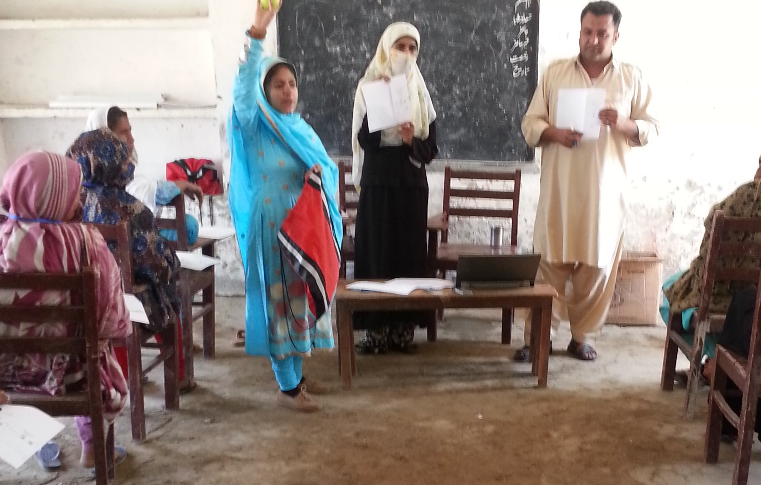

**____________________________________________________________________________________________________________**

**Incentivizing Development: A Field Experiment on Third Tier Organizations in Pakistan Hamna Ahmed and Asha Gul**

This study is a Randomized Control Trial (RCT) being funded by the Pakistan Poverty Alleviation Fund (PPAF). The study focuses on incentivizing development across 800 Local Support Organizations (LSOs) spread across Pakistan by testing the impact of two sustainable measures the donor can take to engage with these community-based organizations: (i) self-reporting and (ii) non-financial incentives.

Collaborators include Kate Vyborny (Duke University) and Simon Quinn (University of Oxford).

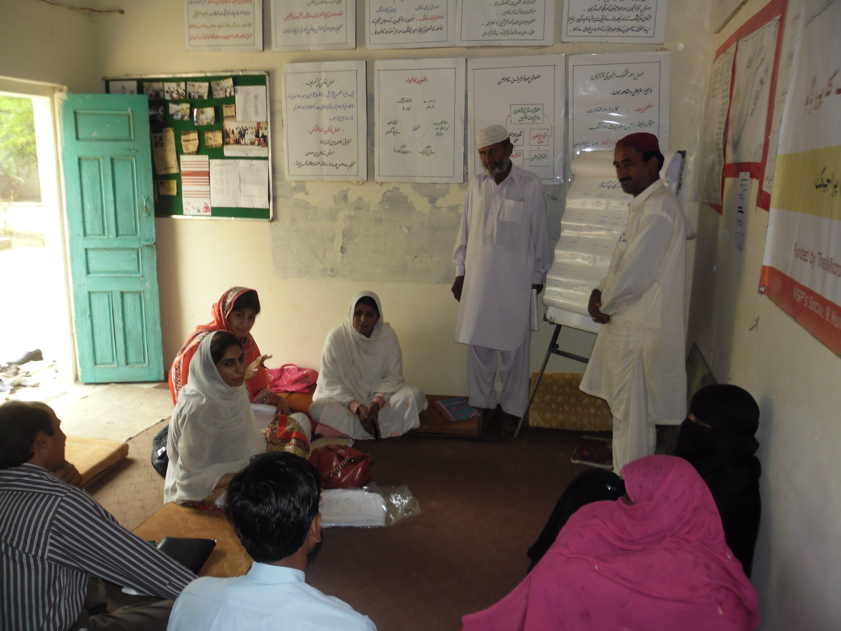

____________________________________________________________________________________________________________

**Technology Management & Innovation Website**

1. Change the highlighted headings

** Department of Economics**

**Technology Management & Innovation Centre**

|  |  |
| --- | --- |
|  | **Technology Management & Innovation Centre**  **Research Agenda**  **Major Research Projects** |

**Home People Major Research Projects Contacts Us**

**Team**

**Home:**

**The Centre for Technology Management & Innovation was established in April 2015 with an aim to promote innovation, a key to growth for Pakistan’s future. The Centre is headed by Dr. Azam Chaudhry, Dean and Professor, Faculty of Economics, Lahore School of Economics.**

**The objectives of the centre are:**

**• Work on firm level research on innovation and productivity.**

**• Conduct surveys with international researchers on innovation and technology.**

**• Collaborate with the government on Policy based research focusing on technological upgradation in the manufacturing sector.**

**• Work with the Lahore Chamber of Commerce and other industrial organizations to promote technological innovation in Pakistan.**

**________________________________________________________________________________________________________________________________________________________**

1. **( Text that would appear in front of the pics)**

**Welcome to the Technology Management & Innovation Centre**

The Technology Management & Innovation Centre (TMIC) at the Lahore School of Economics intends to provide a platform for academics, business, industry and the public sector to work in partnership and find solutions to challenges that matter in areas of economic importance including the manufacturing, exports, readymade garments and textiles.

**Research Agenda**

* Work on firm level research on innovation and productivity.
* Conduct surveys with international researchers on innovation and technology.
* Collaborate with the government on Policy based research focusing on technological upgradation in the manufacturing sector.
* Work with industrial organizations to promote technological innovation in Pakistan.

**Major Research Projects**

1. Analysis of Technology in the Sialkot Soccer Ball industry
2. Benchmarking of Productivity in Pakistan's Readymade Garment Sector
3. Technology and Innovation Mapping Project
4. Measuring Innovation in the Textiles Sector of Pakistan
5. Business Confidence Survey

**_________________________________________________________________________________**

**Technology Management & Innovation Website**

**Please increase the gaps between these headings so that that they are spread out:**

**Home People Major Research Projects Contacts Us**

**________________________________________________________________________________________________________________________________________________________**

**Remove the following picture on the innovation website and replace it with the Fan sector picture given below:**

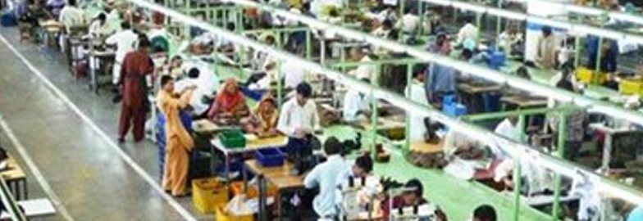

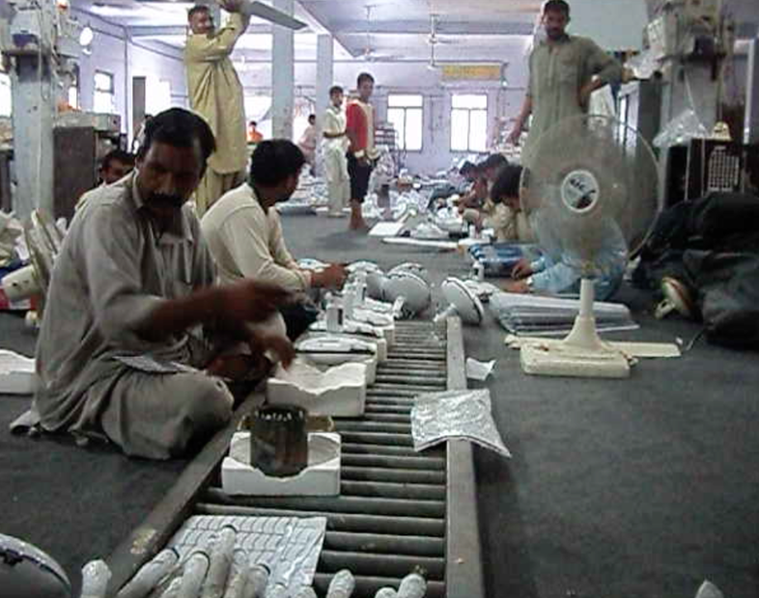

**________________________________________________________________________________________________________________________________________________________**

**Technology and Management Website: Please make the following changes highlighted changes in the team section:**

**Team**

**Azam Chaudhry**

**Professor and Dean, Faculty of Economics & Senior Research Fellow**

**Theresa Chaudhry**

**Professor of Economics & Senior Research Fellow**

**____________________________________________________________________________________________________________**

**Technology and Management Website: Please give page numbers at the bottom of the Major Research Projects Page:**

**Major Research Projects:**

**Page 1 2 Next**

**___________________________________________________________________________________________________________**